Lab Class: Factories and Relationships
Table of Contents
Based on the Lecture Slides and Support Material
Making many instances using a Factory
Creating Multiple Listings
Relationships – belongsTo and hasMany
Many to Many Relationships
Pivot Table
Eager Loading
Mini Challenge

Based on the Lecture Slides and Support Material
You may watch the following videos for step-by-step demo
https://www.youtube.com/watch?v=9O_WD5zQGxM&t=600s
In the tenth episode of the "30 Days to Learn Laravel" series we use factories to allow us to scaffold example data for the purposes of both testing and preparing a local environment with information on the Jobs.
https://laracasts.com/series/30-days-to-learn-laravel-11/episodes/11
In the eleventh episode of the "30 Days to Learn Laravel" focuses exclusively on two key Eloquent relationship types: belongsTo() and hasMany()

https://www.youtube.com/watch?v=x1UCiE0hZiw&t=293s
In Episode 12 of the "30 Days to Learn Laravel 12" focuses on Pivot Tables and BelongsToMany Relationships

Making many instances using a Factory
Open the UserFactory.php and replace the following line
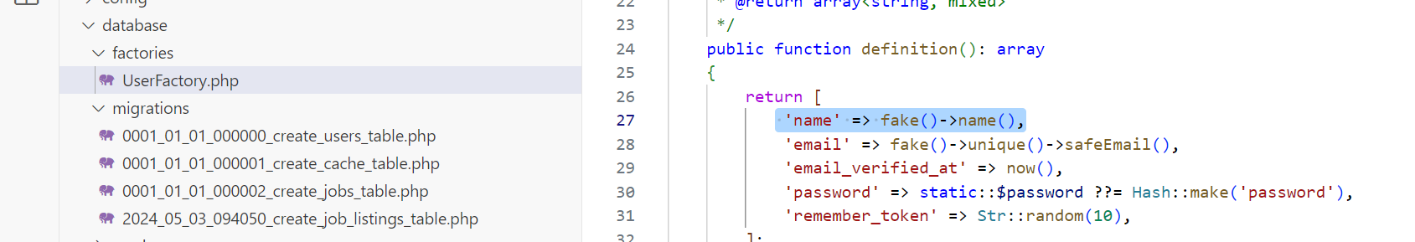
With the one given below. We are doing this because in our database, we have included two columns in the user table (first_name and last_name)
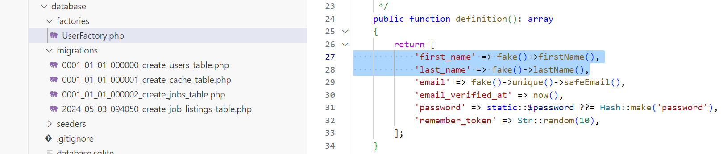
Now open the command line and type ‘php artisan tinker’. Make sure you are inside your project folder:
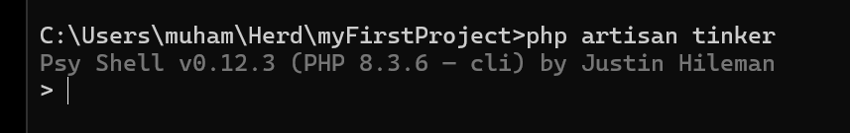
Now run ‘App\Models\User::factory()->create()’ command
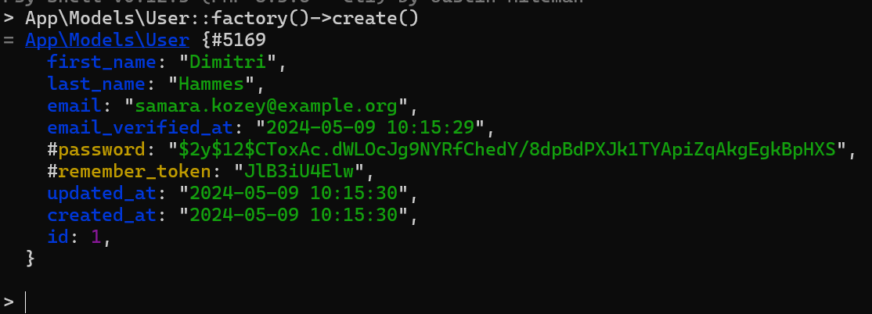
It basically creates a new user record in the user table of the database.
You may open the database in TablePlus to see the newly created user.
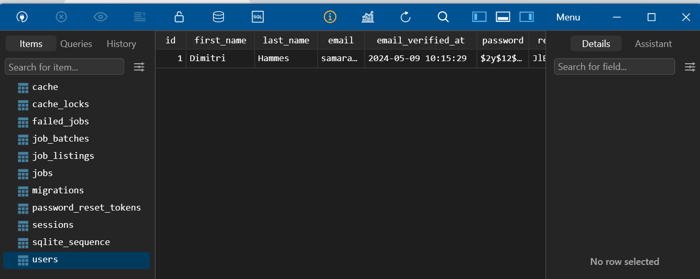
We can also create multiple entries using ‘App\Models\User::factory(10)->create()’. This will create 10 user entries in the database.

Creating Multiple Listings
Now, let’s create multiple job listings using factory. To do this, open the command line and type ‘php artisan make:factory JobFactory’
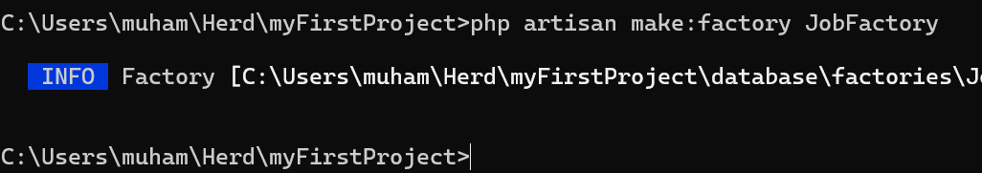
This will create JobFactory.php.
Open this JobFactory.php and add the following
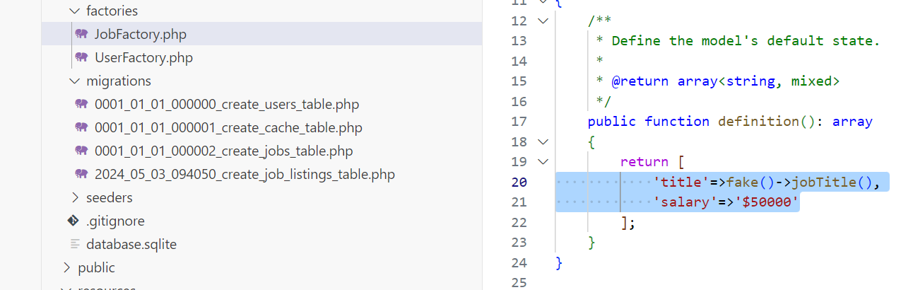
Add the following to the Job.php class
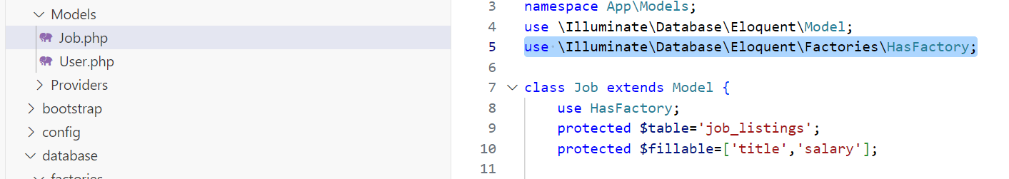
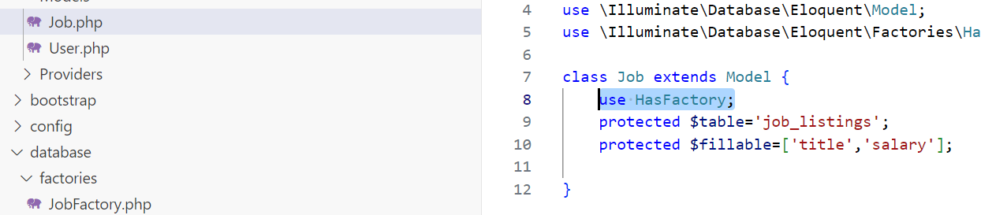
Again, go to tinker on command line (using “php artisan tinker”), and type ‘App\Models\Job::factory()->create()’. This will create a job listing.
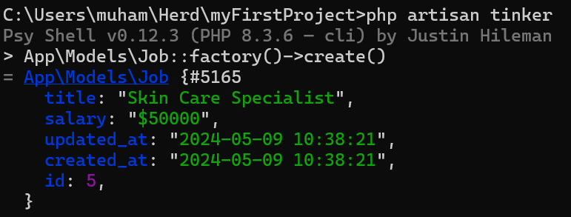
Similarly, the command ‘App\Models\Job::factory(20)->create()’ will create 20 job listings.
Exit tinker by running this command ‘exit()’ .
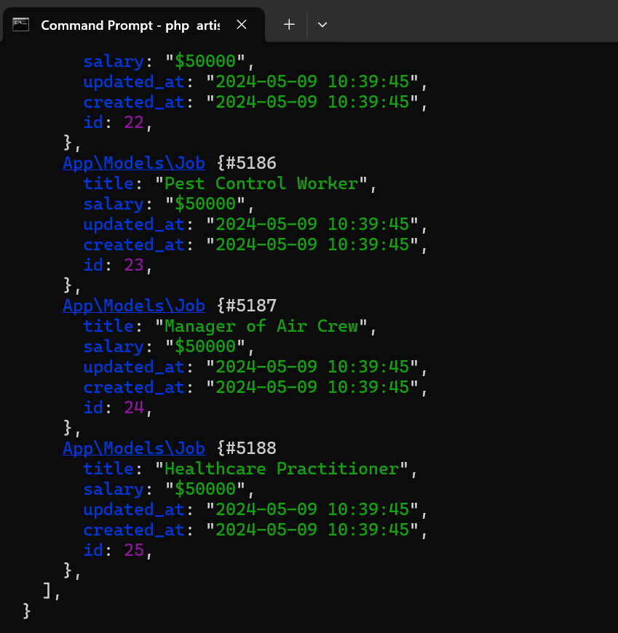
Let’s create a new model along with migration and factory.
Type and run ‘php artisan make:model Employer -m -f’ on the command line.
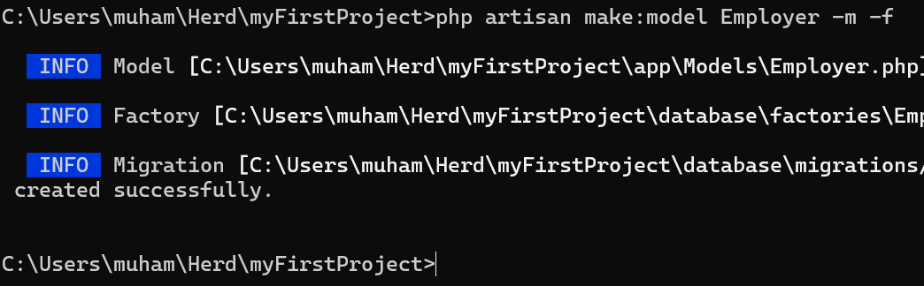
Notice that all three items (model, factory, and migration) are created.
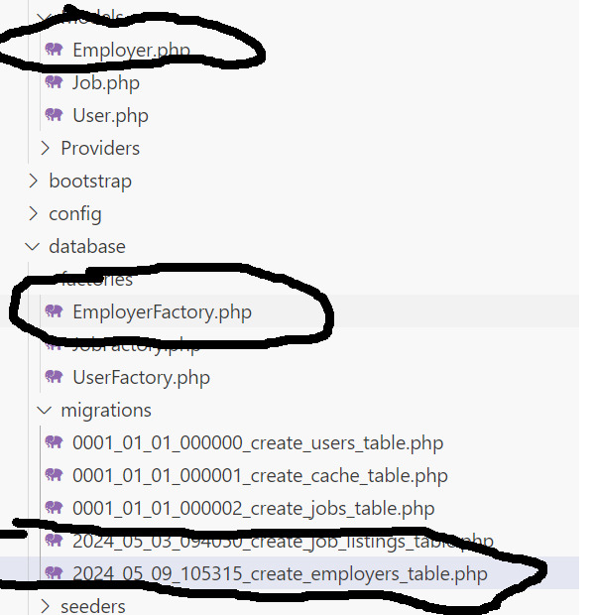

Go to the employer migration and add the ‘name’ field as follows:
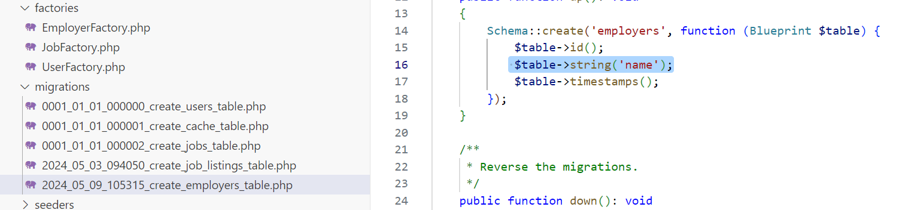
Now lets add a foreign key in the job listing table
Add the following
$table->foreignIdFor(\App\Models\Employer::class);
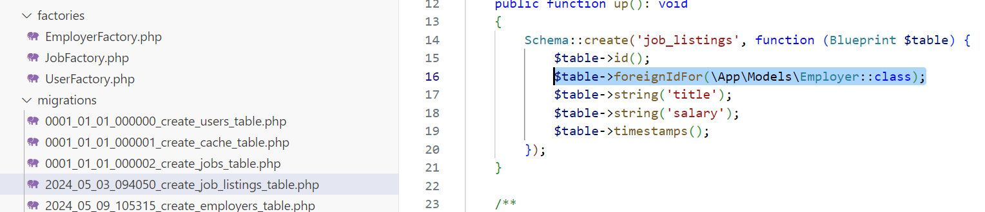
Save all and then run ‘php artisan migrate:fresh’
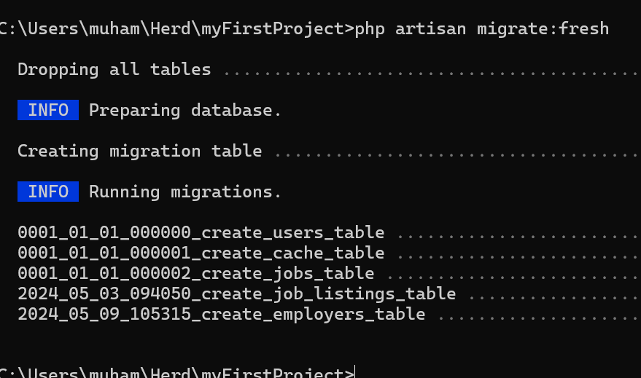
This will remove all the data from our database. Note: Never use this in PRODUCTION
Add the following to JobFactory.php
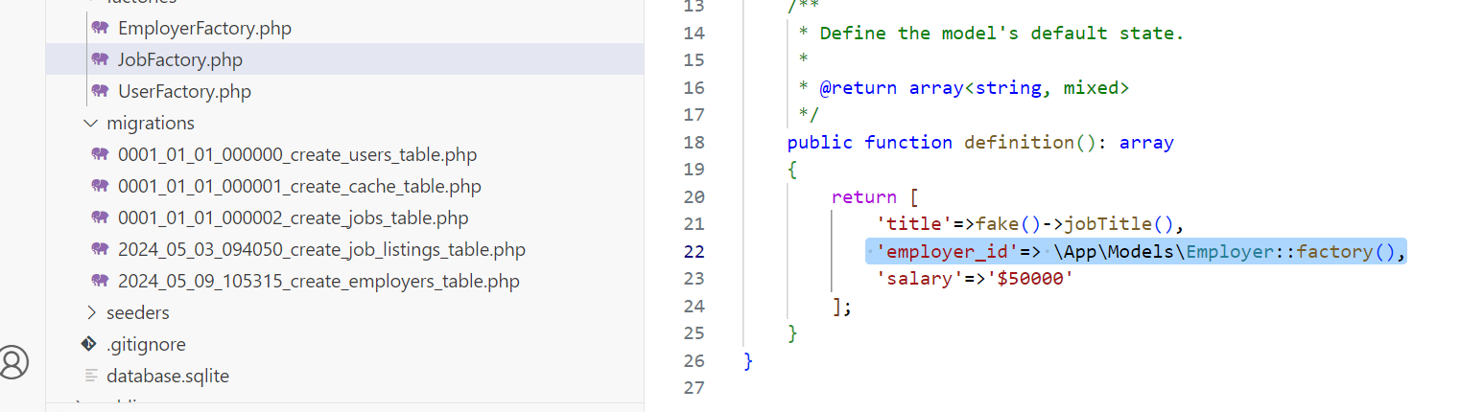
Add ‘'name'=>fake()->company()’ to the EmployerFactory.php
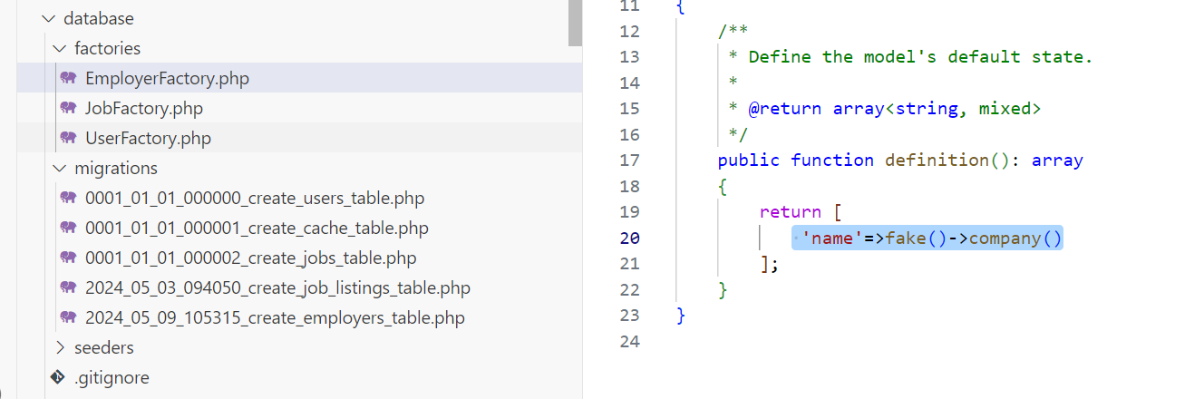
If you get an error of Employer class = not found, just delete Employer factory and model and recreate them using ‘php artisan make:model Employer -f’ command. Make sure you add the one line in the above image to the EmployerFactory.php
Now running the following command will add 20 job listing along with the employers.
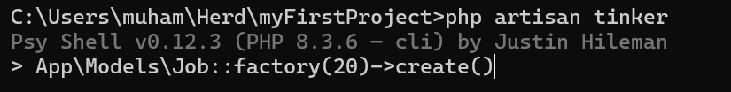

Relationships – belongsTo and hasMany
Now let’s see two key eloquent relationship types: belongsTo and hasMany
Add employer method in the Job.php as follows to access employer information for a specific job
public function employer()
{
return $this->belongsTo(Employer::class);
}

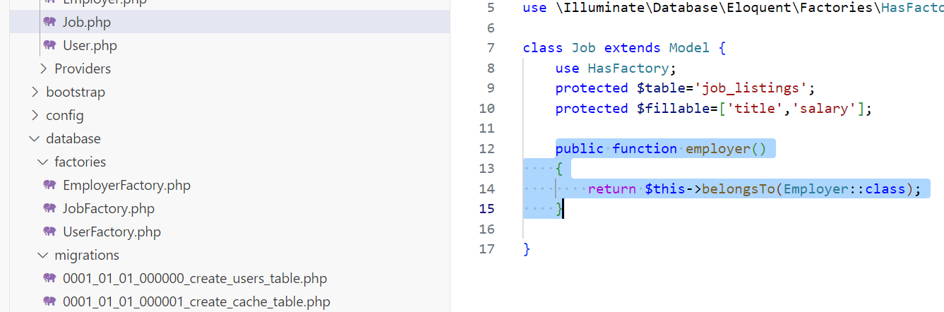
Now let’s see how it works. Open command line and then go to tinker by typing
‘php artisan tinker’.
Type ‘$job=\App\Models\Job::first() ‘ to get details of the first job.
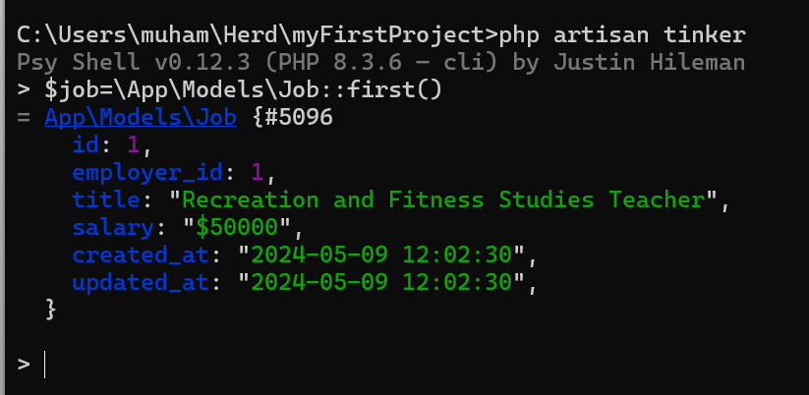
Since we have already defined the ‘belongsTo’ relationship, we can access the employer information as follows
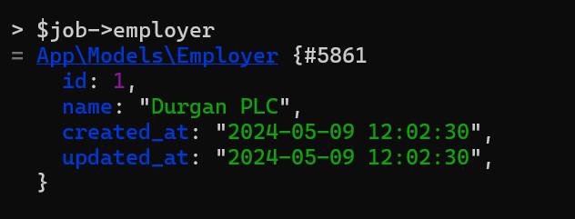
We can access any individual attribute as
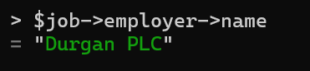
Now to access jobs for a particular employer, we have to use ‘hasMany’ relationship because an employer can have more than one job. To do this, lets add jobs() method to the employer class as follows:
public function jobs()
{
return $this->hasMany(Job::class);
}

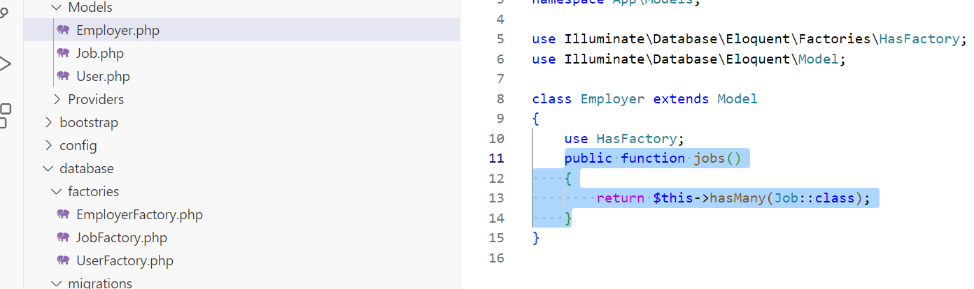
Let’s get the first employer by typing ‘$employer=App\Models\Employer::first()’
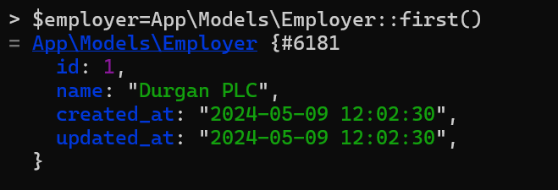

Now let’s get the associated jobs for this employer
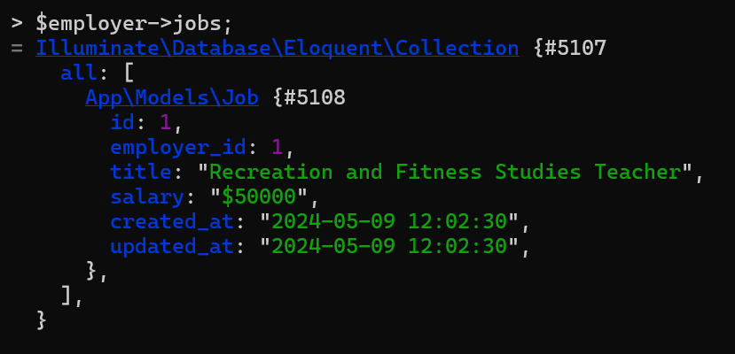
Notice, it’s a collection.
We can use the individual job here like an array
$employer->jobs[0]
Or like a collection
$employer->jobs->first()
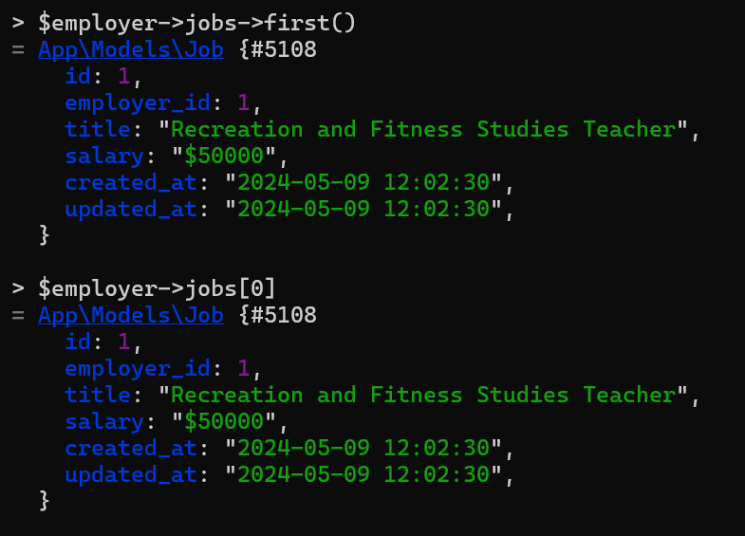

Many to Many Relationships
Next, we are going to deal with the many to many relationships. An example would be vacancy and tag, a single vacancy may belong to more than one tag and a tag may belong to more than vacancy. We use ‘belongsToMany’ relationship and a pivot table for this.
First, let’s create the ‘Tag’ model along with the migration and factory. To do this, we need to type ‘php artisan make:model Tag -mf’ command
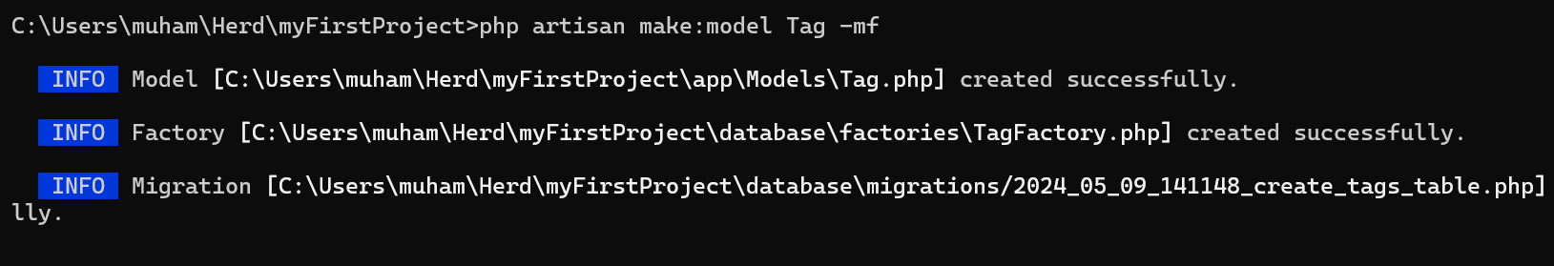
Let’s go to the newly created migration and add the name attribute as follows
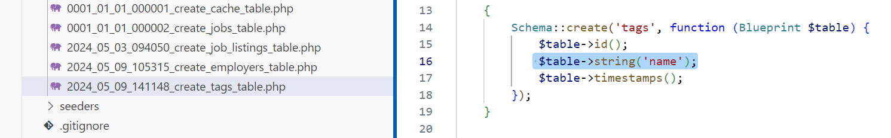

Pivot Table
Please make sure you watch the related LaraCast video for Pivot Tables
Now let’s create the pivot table
Schema::create('job_tag', function (Blueprint $table) {
$table->id();
$table->foreignIdFor(\App\Models\Job::class,'job_listing_id')->constrained()->cascadeOnDelete();
$table->foreignIdFor(\App\Models\Tag::class)->constrained()->cascadeOnDelete();
$table->timestamps();
});
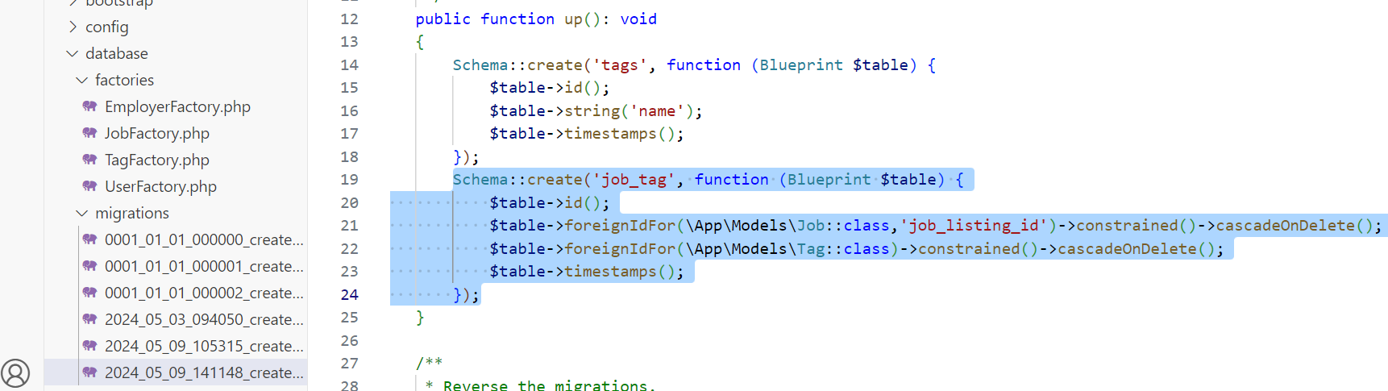

Notice that the ‘job_listing_id makes sure that our own table is referenced rather than the built in ‘Job’ table in the line’ $table->foreignIdFor(\App\Models\Job::class,'job_listing_id');
Type ‘php artisan migrate’ command and then you can see the database in TablePlus with new tables created
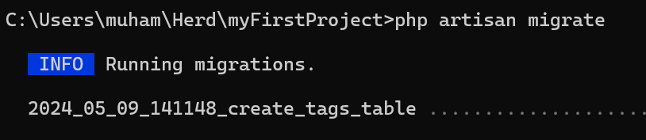
To turn on foreign key constraints in SQLite, go to TablePlus, select SQL and write ‘PRAGMA foreign_keys=on’ and click ‘Run current’
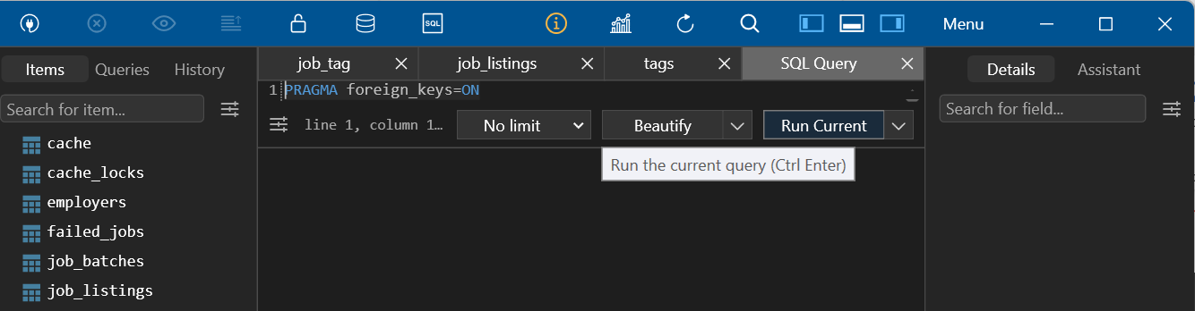
Let’s add a tag entry in the database
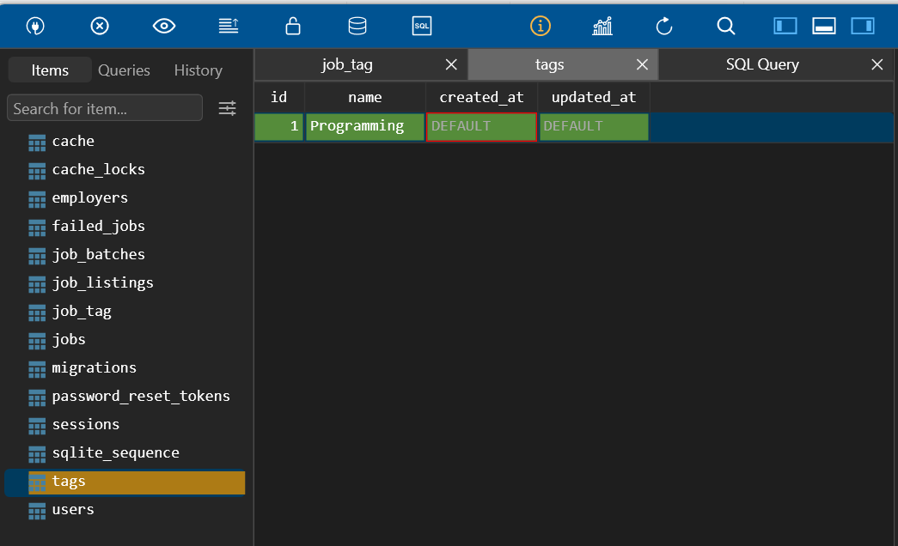
Make sure you commit any changes through the commit button as follows:
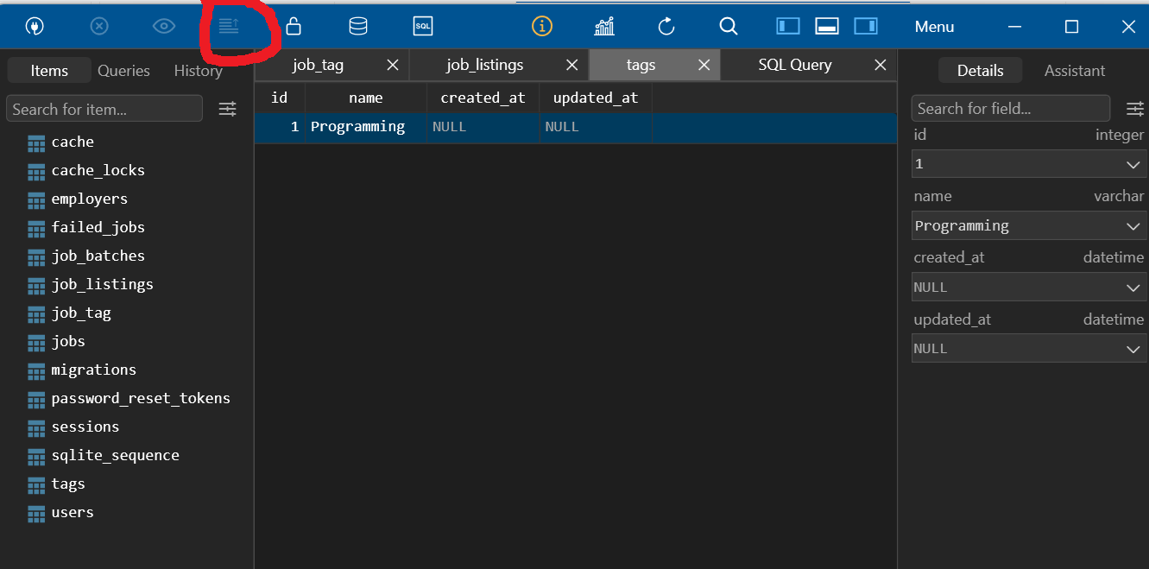

Let’s add a job as well
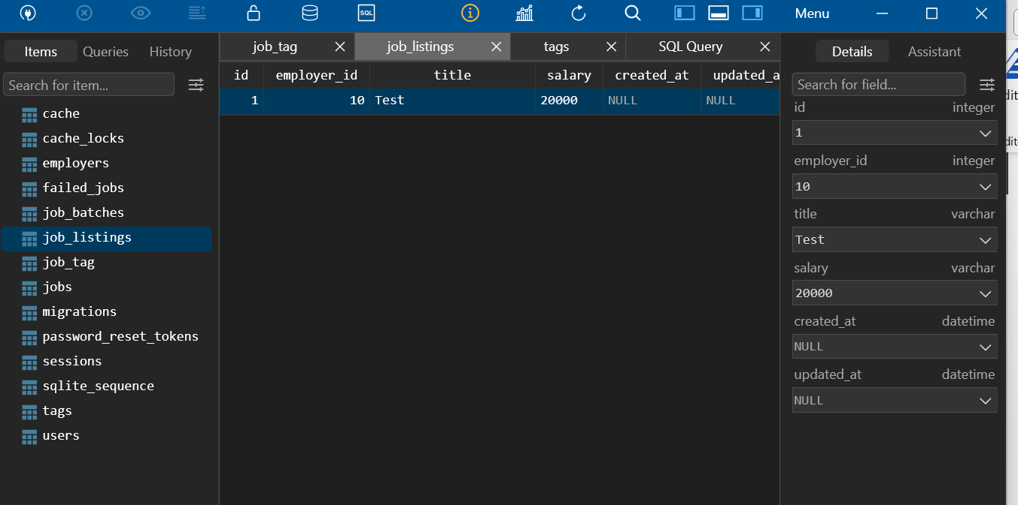
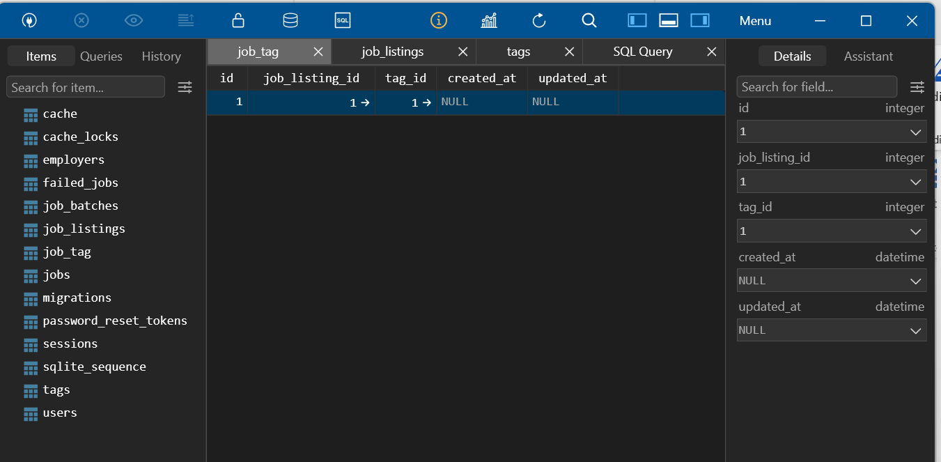
Now delete the data from the tags table and you will see the data from ‘job_tag’ table also gets deleted due to the foreign key constraint.

Eager Loading
https://laracasts.com/series/30-days-to-learn-laravel-11/episodes/13
Eager Loading and what is the N+1 problem? And then how to deal with it.

Mini Challenge
Try out this git repo as a zipfile located in the Week 5 on BBU:
Job_Listings_Project-with_Ratings_Relationships.zip
JOBS with RATINGS
Uncompress the zipfile and:
Use composer install
Use npm install
Use npm run dev
There is no dB retained from the zipfile, so you need to use the php artisan migrate to Migrate and proceed to seed and view the results:
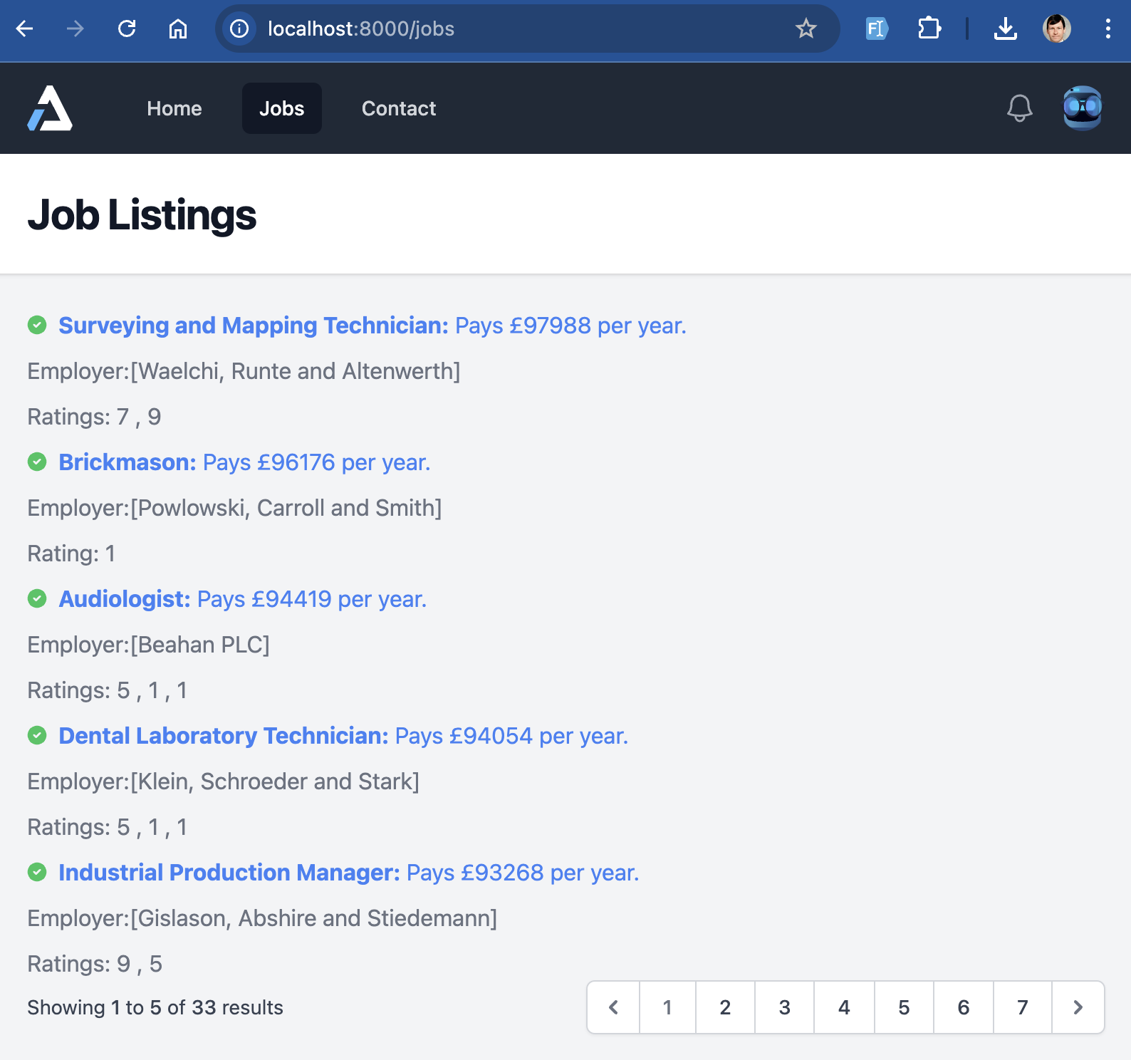
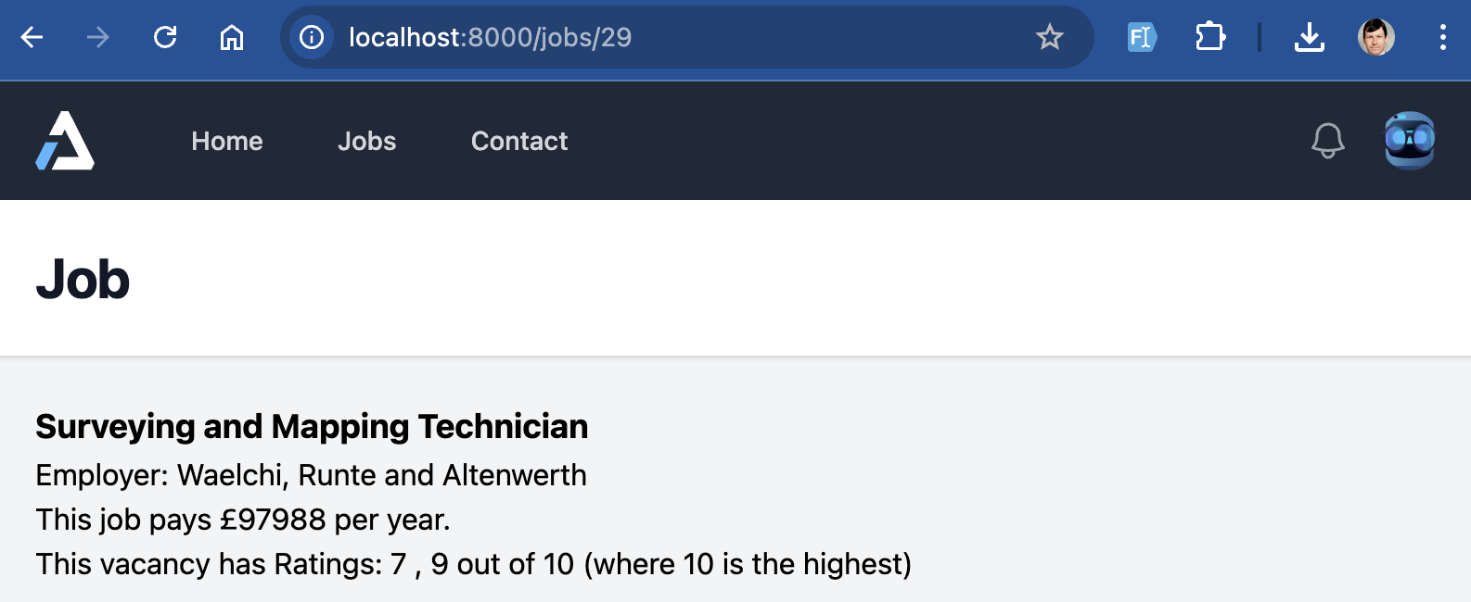
TablePlus
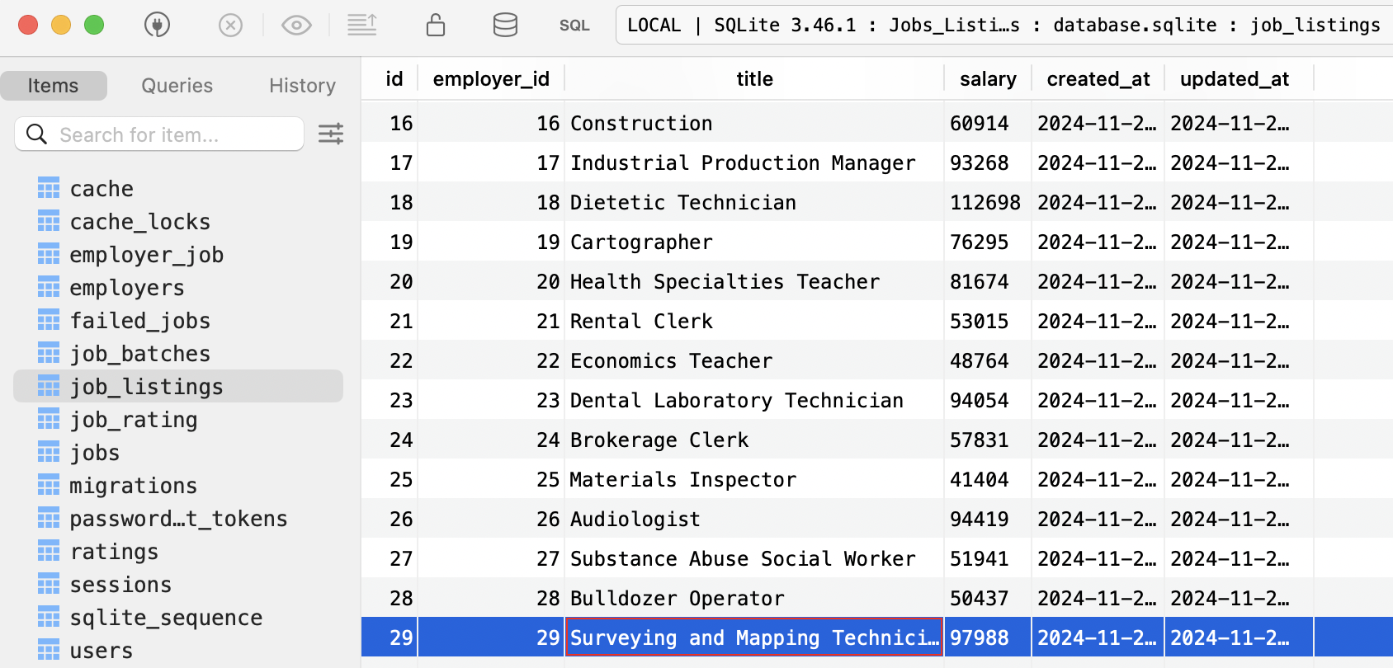

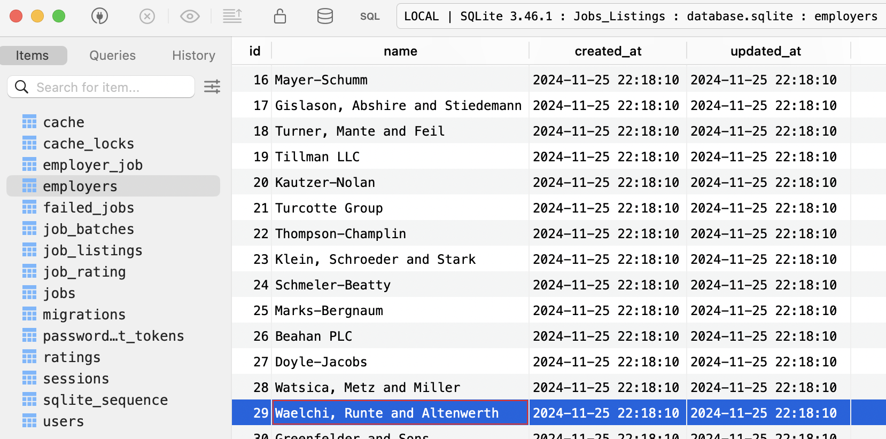

Construct the 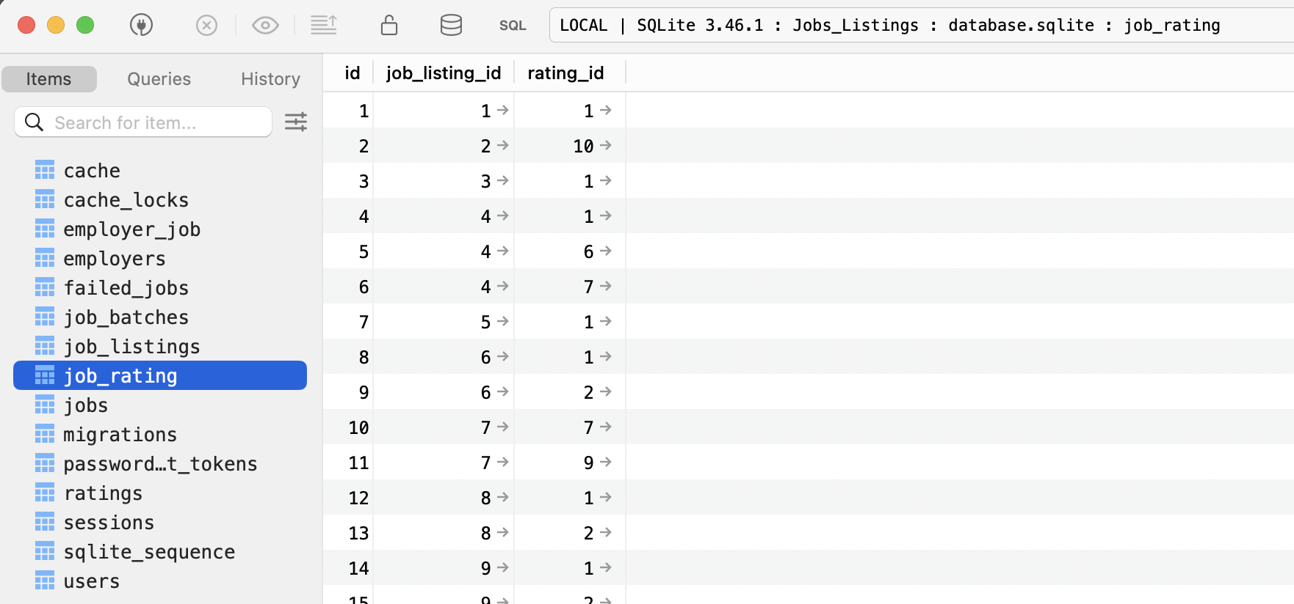
Create your own Models for the following relationship:
A person (User) has many Books
Using belongsTo and hasMany
Make instances using Factories for 10 Users each with 5 books.
View the results both in Tinker and TablePlus

